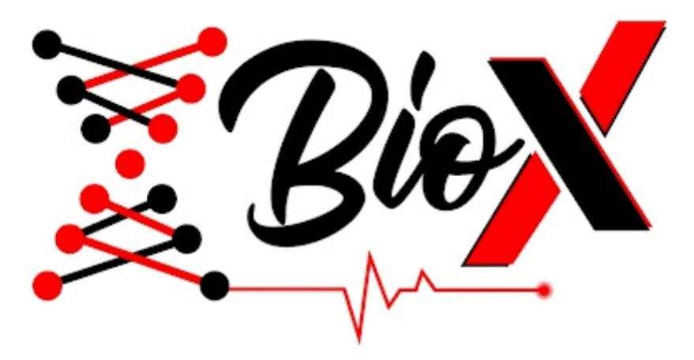

EVOLUTION101

LEARNER’S SPACE ‘25

WEEK 3

**Reading Material:**

## **Coevolution**

Evolution is not a solo journey. In nature, organisms constantly interact — they compete, help each other, avoid predators, or find new hosts. When two or more species influence each other’s evolutionary path through these interactions, we call it **coevolution**.

**Coevolution** is the process by which **two or more species reciprocally affect each other's evolution**. Each species acts as a **selective pressure** on the other, often resulting in a back-and-forth dynamic of adaptation and counter-adaptation.

Example: As a flower evolves a deeper nectar tube, the pollinator evolves a longer feeding structure (like a tongue or proboscis) to reach it.

* [Stories of coevolution](https://youtu.be/-aP0ScRA6n8?si=b3XLD6zYdsDuvqxk)

## **Mutualism: Coevolution that Benefits Both**

In **mutualistic coevolution**, both species benefit from the interaction and evolve in ways that enhance their partnership.

### **Example 1: Pollinators and Flowers**

* **Flowers** evolve bright colors, scents, and nectar to attract pollinators.
* **Pollinators** (like bees, hummingbirds, bats) evolve body parts and behaviors that efficiently gather nectar and transfer pollen.

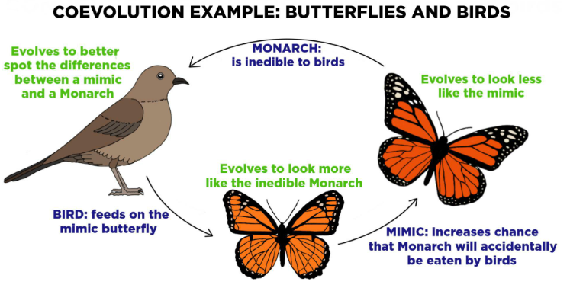

### **Example 2: Ants and Acacia Trees**

* **Acacia trees** grow hollow thorns and provide sugary nectar.
* **Ants** live inside the thorns and aggressively defend the tree from herbivores.

### **Result:**

* Both species develop **specialized structures and behaviors**.
* Neither species would thrive as well without the other.

Video Resource:[Mutualism](https://youtu.be/7rSbqYbFlLk?si=l1eNX4urKpHuYHJA)

## **Predator-Prey Arms Races: The Red Queen Effect**

**Antagonistic coevolution** happens when one species evolves to exploit another, and the other evolves defenses — often called an **evolutionary arms race**.

Inspired by the Red Queen in *Alice in Wonderland*, who says: “It takes all the running you can do to stay in the same place.”

### **Example 1: Cheetahs and Gazelles**

* **Gazelles** evolve to run faster to escape.
* **Cheetahs** evolve to run even faster to catch them.

### **Example 2: Newts and Garter Snakes**

* **Rough-skinned newts** produce a deadly toxin (TTX).
* **Garter snakes** evolve resistance to the toxin — but it slows them down.

### **Key Dynamics:**

* One species evolves a **defense** (speed, toxin, camouflage).
* The other evolves an **offense** (speed, resistance, better hunting ability).
* Often leads to **extreme adaptations** over time.

## **Why Coevolution Matters**

* Explains the **tight fit** between interacting species.
* Drives **diversity** and **specialization**.
* Helps us understand dynamics in **ecosystems**, **disease evolution**, **agriculture**, and **mutualistic technology design** (like bio-inspired AI).

Video resource:

* [Coevolution: Evolutionary arms race](https://youtu.be/hmxm3tLcTAg?si=Y0fxK1auYWLrVZkM)
* [Predator- prey evolution](https://youtu.be/IWNf7GOkJuU?si=mB0TDd7RMlgFPCDv)
* [Coevolution :Case of Durant vs Heatmor](https://youtu.be/RQWfZeENFqs?si=FcnaeOBgQDW7vS8s)

**Python Basics**

Refer the PDF and source code - [Python Basics](https://drive.google.com/drive/folders/1MvnGkndiJLgP_MlZCK7_wtvyS10uuRzt?usp=sharing)

**Biopython**

**Biopython** is an open-source Python library designed for **computational biology and bioinformatics**. It provides easy-to-use tools to read, write, analyze, and manipulate biological data such as DNA, RNA, and protein sequences.

To learn Biopython refer the tutorial -[https://biopython.or g/docs/latest/Tutorial/index.html](https://biopython.org/docs/latest/Tutorial/index.html)  
BioPython references:

<https://youtu.be/HcjR99SPNNM?feature=shared>

<https://youtu.be/PoycwO8vuc0?feature=shared>

<https://youtu.be/DAbtTZbYiXA?feature=shared>

## **Sequence Databases**

**Sequence databases** are repositories that store nucleotide (DNA/RNA) and protein sequences from organisms across the tree of life. These databases are critical for comparing sequences, annotating genes, and understanding evolution.

### **Types of Sequence Databases**

#### **1. Primary Databases (Raw experimental data)**

| **Database** | **Description** | **Examples of Entries** |
| --- | --- | --- |
| **GenBank** (NCBI) | Annotated DNA sequences | Human genes, bacterial plasmids |
| **EMBL** (EBI) | European version of GenBank | Same data, different interface |
| **DDBJ** (Japan) | Japanese partner in data sharing | DNA sequences |

These three are synchronized daily under the **International Nucleotide Sequence Database Collaboration (INSDC)**.

#### **2. Protein Databases**

| **Database** | **Description** |
| --- | --- |
| **UniProt** | High-quality protein sequences and functions |
| **PDB** | 3D structures of proteins |

#### **3. Specialized Databases**

| **Database** | **Focus Area** |
| --- | --- |
| RefSeq | Curated reference sequences |
| Ensembl | Genome data (especially human) |
| SILVA | rRNA sequences |
| PFAM | Protein families and domains |

## **BLAST – Basic Local Alignment Search Tool**

**BLAST** is a tool that finds **regions of local similarity** between biological sequences (nucleotide or protein). It’s used to identify:

* Similar sequences in databases,
* Evolutionary relationships,
* Possible functions of unknown genes.

You give it a query sequence, and it searches databases to find similar sequences.

**SEQUENCE ALIGNMENT CONCEPT:**

* [Sequence alignment -types and method](https://youtu.be/MzxNWwNpuFg?si=kpfnQDPsoQLGeCPV)
* [Pairwise alignment](https://youtu.be/Qf7gNvYrfwg?si=o18KPaBzaEWnmBcZ)
* [Multiple sequence alignment](https://youtu.be/774N0pTeUQU?si=wV_cF8HuQjL2gym6)
* [Sequence alignment](https://youtu.be/PoycwO8vuc0?si=if7Ia1wY8iq-A0Zu)

**Epigenetics:**

**Introduction:**

Epigenetics is the study of changes in gene expression that occur without altering the underlying DNA sequence. These changes affect how genes are turned on or off and are influenced by environmental factors, developmental stages, and lifestyle choices. Unlike mutations, which change the genetic code itself, epigenetic modifications are reversible and can sometimes be inherited across generations.

**Mechanisms of Epigenetic Regulation:**

Epigenetic changes work through several mechanisms. One of the most common is DNA methylation, where methyl groups are added to DNA molecules, usually silencing gene activity. Another important mechanism is histone modification, which involves chemical changes to the proteins around which DNA is wound. These modifications can tighten or loosen the DNA structure, controlling access to genes. Additionally, non-coding RNAs can influence gene expression by interfering with the translation process or guiding other epigenetic changes.

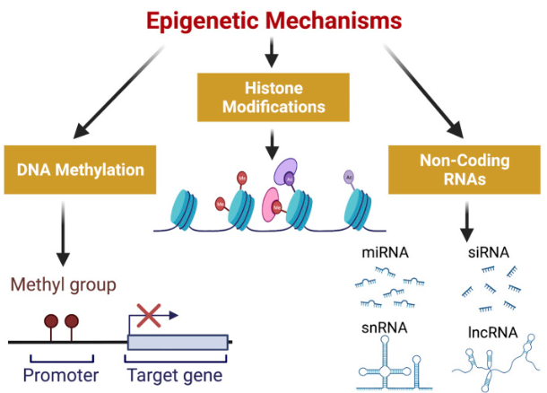

Fig 1 : **Epigenetic Mechanisms involved in gene expression**: DNA methylation, Histone Modifications and Non-Coding RNAs constitute the three mechanisms involved in epigenetic regulation of gene expression. Methylation of DNA occurs at gene promoters and hypermethylation represses gene expression. Histone modifications include acetylation and methylation of histones which can either activate or repress gene expression. Non-coding RNAs which consist of short chain non-coding RNAs ( <200 nt) and long non-coding RNAs ( >200 nt) also play a significant role in regulation of gene expression. (Created with [BioRender.com](http://biorender.com/)). Ac, acetylated histone; Me, methylated histone; miRNA, micro RNA; siRNA, small interfering RNA; snRNA, small nuclear RNA; lncRNA, long non-coding RNA.

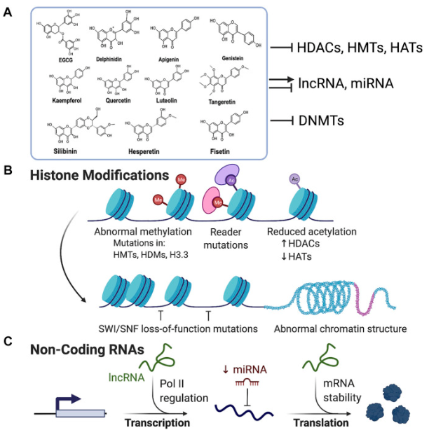

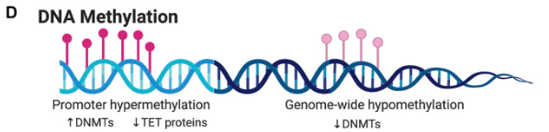

Fig 2: **Flavonoids as epigenetic modulators in cancer:** (A) Flavonoids are polyhydroxy compounds found in various plants and generally consist of two phenyl rings and a heterocyclic ring. Flavonoids are reported to exhibit inhibitory activity for HDACs, HMTs, HATs, and DNMTs. They can also either inhibit or activate miRNA and lncRNA. (B) Illustration showing various mechanisms of histone modifications associated with carcinogenesis. Flavonoids can block the aberrant expression of HMTs, HATs, and HDACs, and activate tumor suppressor genes and block the expression of oncogenes. (C) Flavonoids can either activate or repress non-coding RNAs which regulates chromatin structure and aberrant gene expression in cancer. (D) Promoter hypermethylation and genome-wide hypomethylation are associated with cancer. Flavonoids can inhibit DNA Methyl Transferases (DNMTs) and thus prevent hypermethylation of gene promoters like tumor suppressor genes thereby reactivating their expression.

**Importance of Epigenetics in Biology:**

Epigenetics plays a crucial role in cell differentiation, development, and adaptation. For example, although every cell in the body has the same DNA, epigenetic mechanisms ensure that only certain genes are active in each cell type—allowing nerve cells, muscle cells, and skin cells to function differently. Epigenetics also helps organisms respond quickly to environmental stressors without changing their genome, making it a powerful layer of biological regulation.

**Epigenetics and Human Health:**

Many diseases, including cancer, neurological disorders, and autoimmune conditions, are linked to faulty epigenetic regulation. For instance, if a tumor-suppressor gene is mistakenly silenced by DNA methylation, it can lead to uncontrolled cell growth. Epigenetics also helps explain why identical twins, who have the same DNA, can show differences in traits or disease susceptibility due to different life experiences or environmental exposures.

**Epigenetics in Evolution and Inheritance:**

Epigenetic changes can sometimes be passed from one generation to the next, providing a link between the environment and inherited traits. A famous example is the Dutch Hunger Winter, during which children of malnourished mothers showed long-lasting health effects caused by epigenetic changes during fetal development. In evolutionary terms, epigenetics offers a way for populations to adapt quickly to changing environments, even before genetic mutations occur.

Video Resources:

* [Epigenetics](https://youtu.be/_aAhcNjmvhc?si=h_KChFfqo6rVn8-e)
* [Intro to epigenetics](https://youtu.be/IAu44BkOaSs?si=VBI7XDpMcPoXRQUD)
* [Inheritance](https://youtu.be/W9SViazIH00?si=FzTCPQ5rpUSh_B6t)